**Mohammed mujahed:batch-16**

**Git-github-challenges**

1. **Resolve Merge Conflicts**
   * Create a merge conflict intentionally (two users editing the same line).

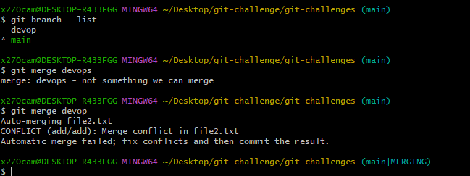

Steps: first create new branch <git branch feature> and switch to this and create a file and write content and tracking then commit this file.

# then go to main branch and create same file with same content then <git merge feature>then it will conflict

* + Resolve the conflict and push the changes.

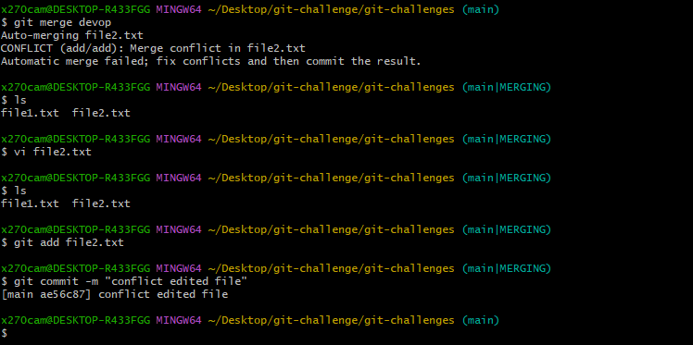

Steps: to resolve the conflict edit the file .and remove the arrays.

1. **Recover Deleted Branch**
   * Delete a local branch and then recover it using the reflog.

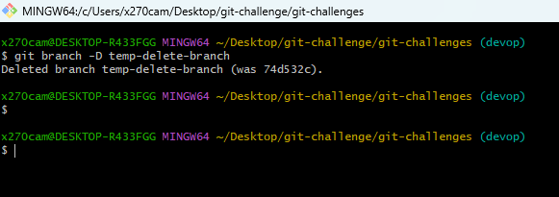

Steps:first I created a branch with <git checkout –b temp-delete-branch>

#then delete this branch by change to anetor branch then delete<git branch –D “branch name”>

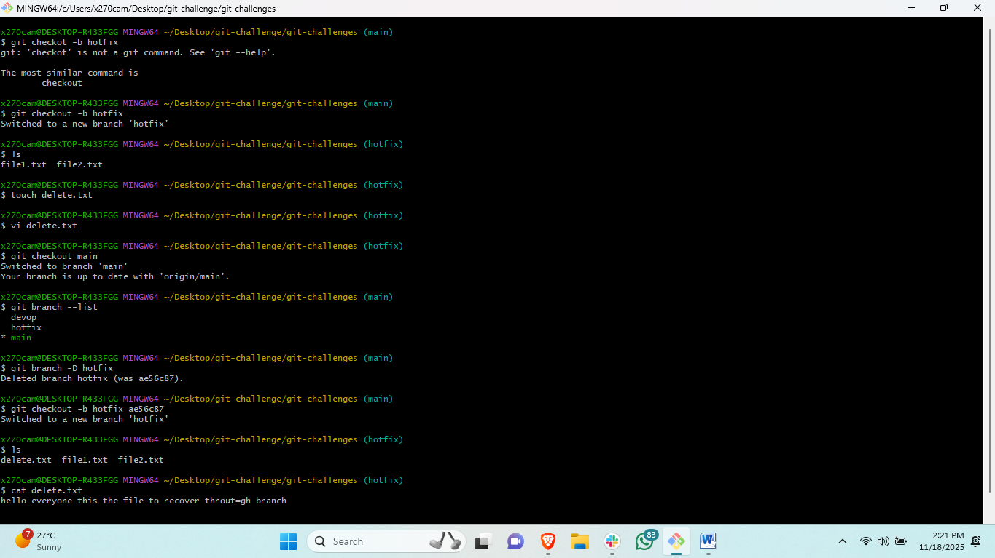

Steps: first create a branch and make a file in branch and the checkout to another branch and delete this branch <git branch –D “branchname”>

#then recover this branch by using <git checkout –b “recoverybranchname” and commit Id which show after deleting the branch>.

#then checkout to recover branch and check the previous created files are available or not.

1. **Undo Wrong Push**

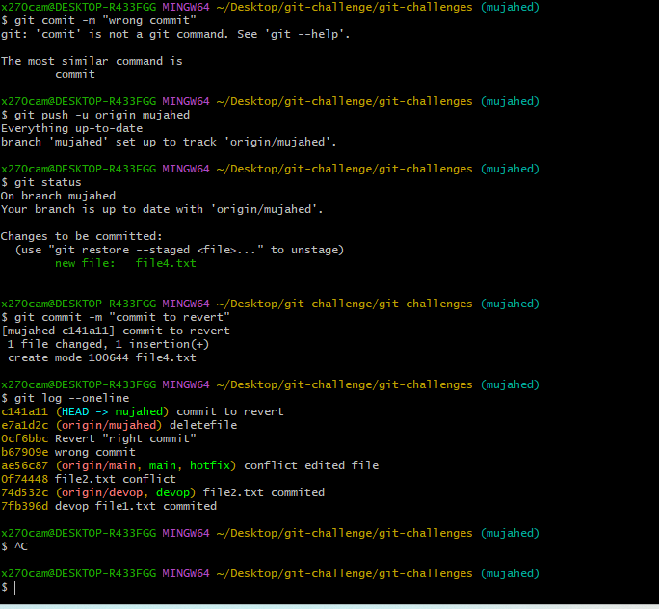

* + Push a wrong commit to GitHub, then undo it without losing history.

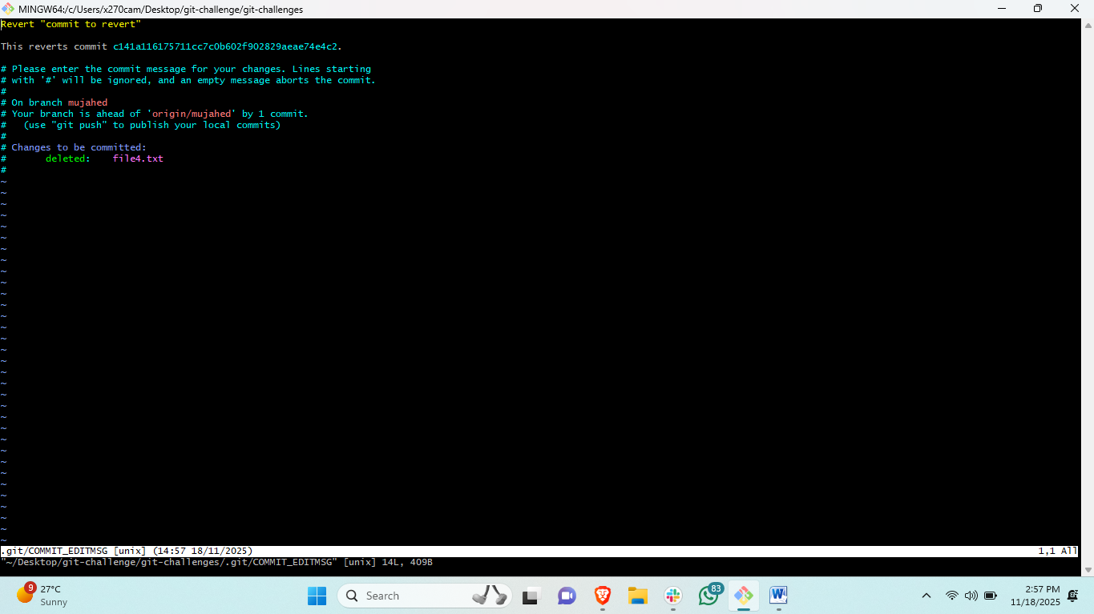

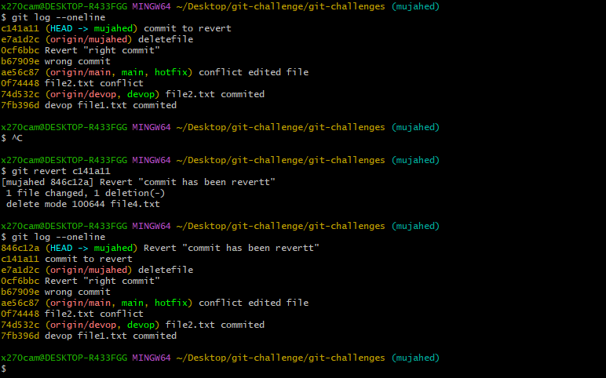

Steps: if you created a file or anything and commited and push to your central repository.

#then you have to re-write your comit do<git log –oneline> and remember the commit id

#then <git revert “commit id>

#and add your commit message and save.

#then check the update<git log --oneline>

1. **Amend a Commit**

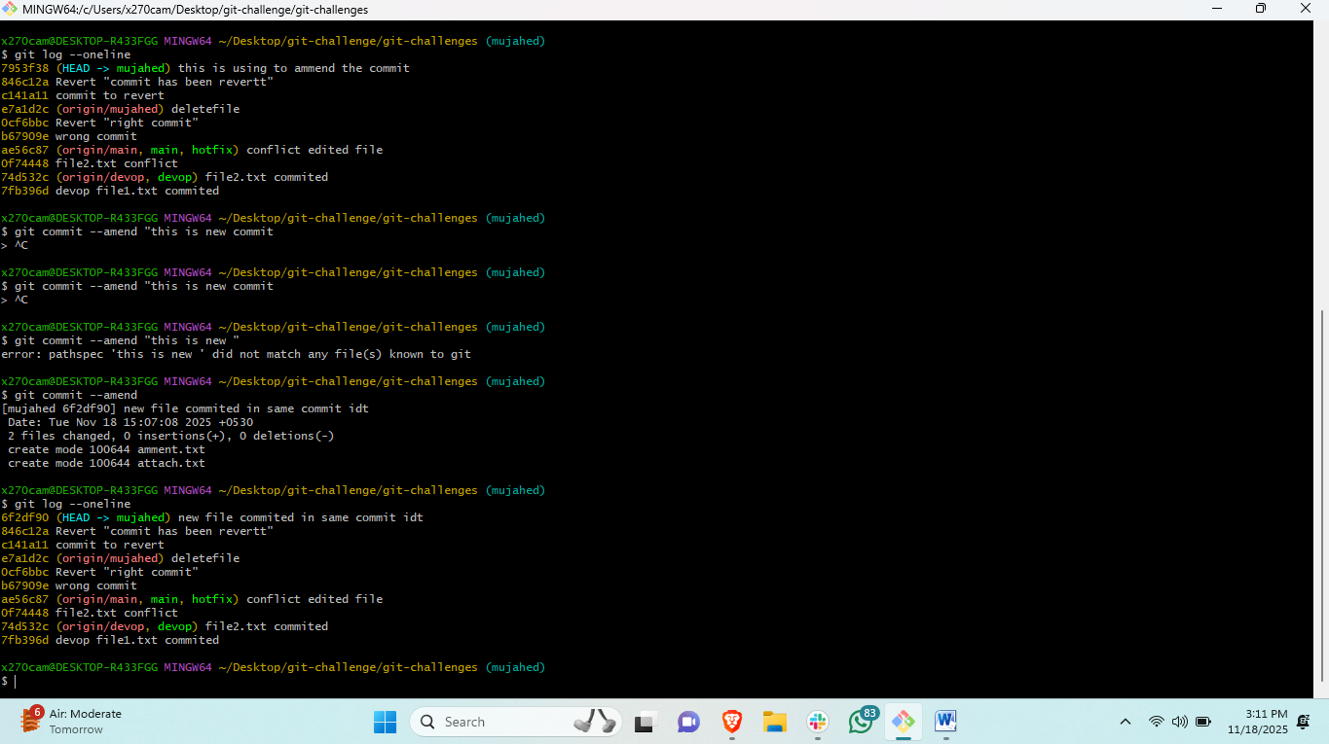

Steps: if you created a file and add to tracking area and the commit thisfile but you have add anethor file in the same commit the use this <git commit --amend> it will add anethor file in same commit id.

* + Make a commit, then add a missing file to it using git commit --amend.

1. **Cherry-pick a Commit**
   * Take a specific commit from one branch and apply it to another branch.

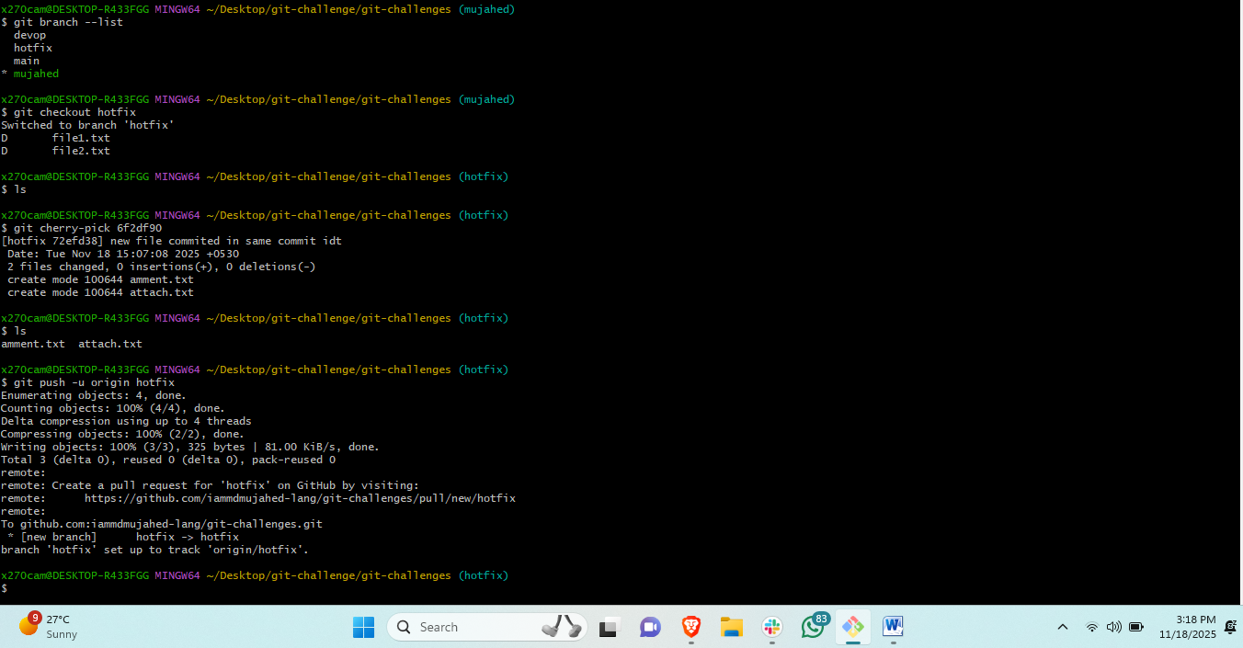

Steps:what is cherry-pick if you have a commited files in branch-A and you need to get it in branch-B

#then change to branch-B and <git cherry-pick “commit id”>

#then push to central of branch-B<git push –u origin branch-B>

1. **Interactive Rebase**
   * Reorder and squash multiple commits into a single clean commit.

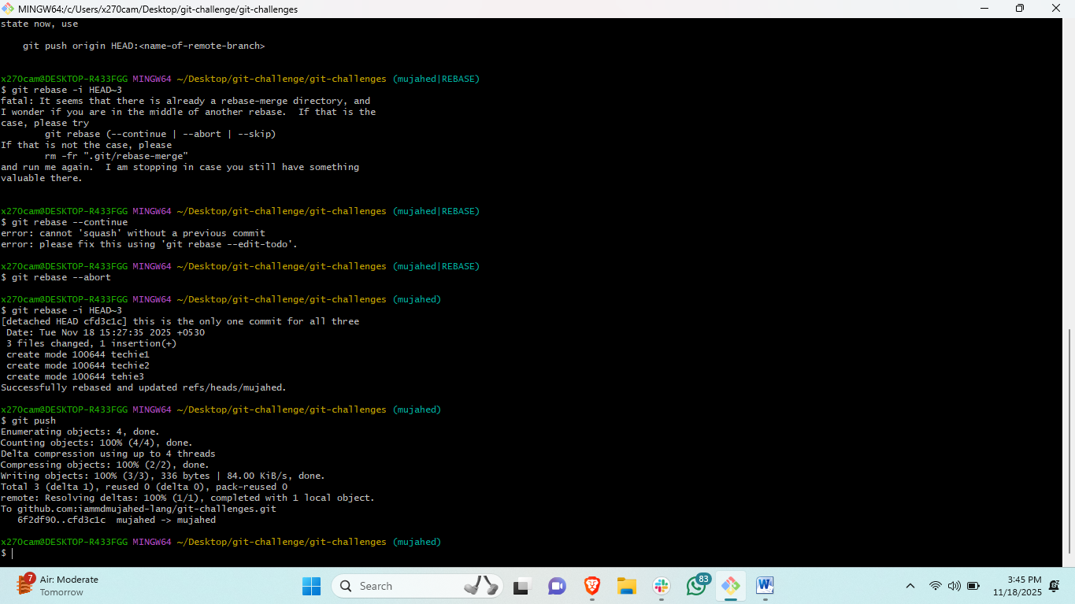

Steps: the reason we are doing rebase is if you are having multiple commit then need to keep all this commit in a single comit.

#create three files and commit this with different commit id’s   
#and then <git rebase –I HEAD~3>

#then edit the file and rename file2 and file3.

#then check the commit logs <git log --oneline>

1. **Tagging & Release**
   * Create a version tag (v1.0), push it to GitHub, then delete and restore it.

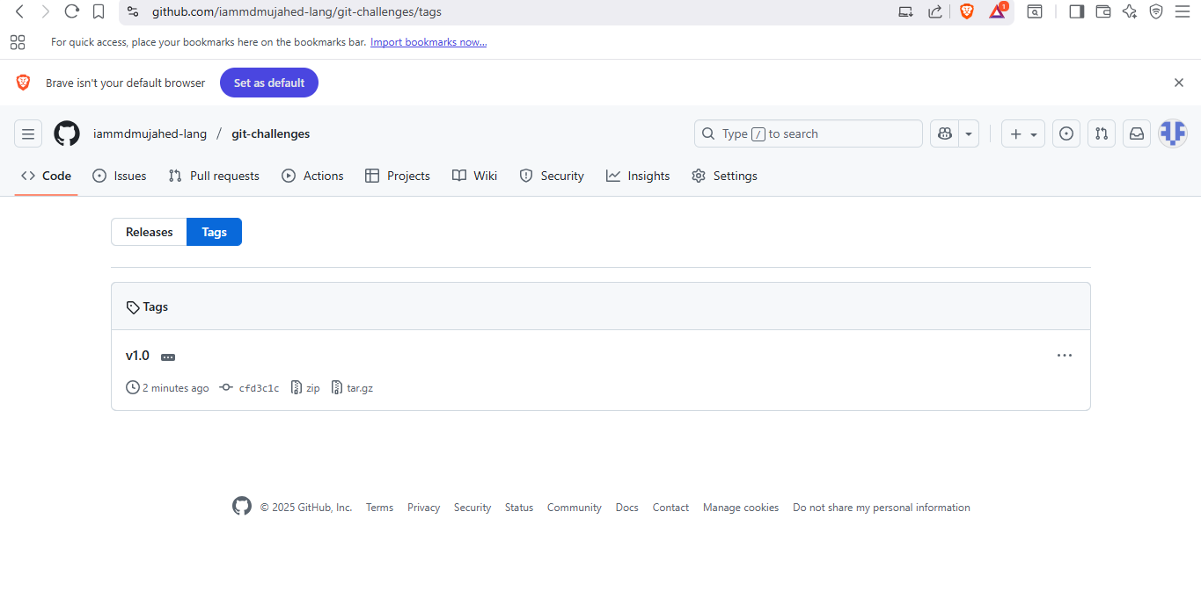

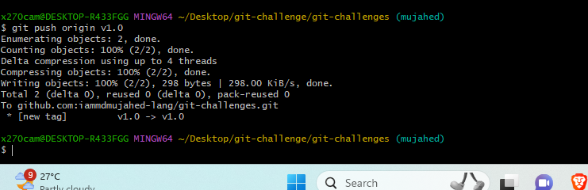

# Create tag

git tag -a v1.0 -m "Release v1.0"

# Push tag

git push origin v1.0

# Delete local and remote tag

git tag -d v1.0

git push origin :refs/tags/v1.0

# Restore tag from commit (e.g., commit abc123)

git tag -a v1.0 abc123 -m "Restore v1.0"

git push origin v1.0

1. **Clone with Sparse Checkout**
   * Clone only a subdirectory of a repo using sparse checkout.

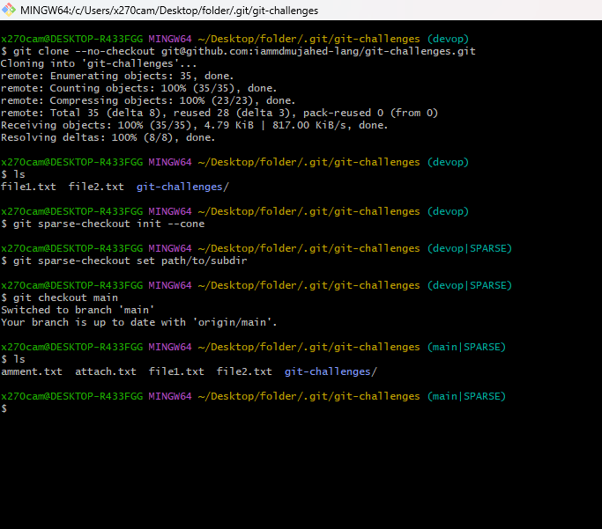

git clone --no-checkout <repo-url> myrepo

cd myrepo

git sparse-checkout init --cone

git sparse-checkout set path/to/subdir

git checkout main.

1. **Reset vs Revert Challenge**
   * Demonstrate the difference between git reset --hard and git revert in a repo.

g

1. **Detached HEAD Challenge**
   * Checkout a specific commit (detached HEAD state) and create a new branch from it.

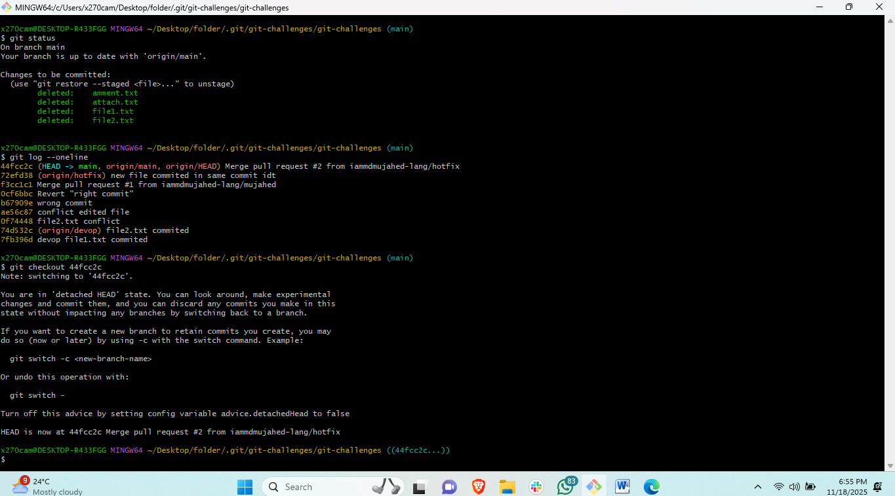

git checkout <commit-hash>

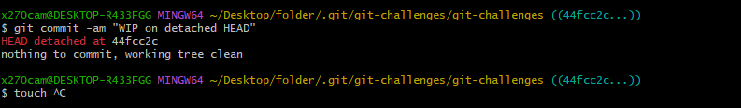

git commit -am "WIP on detached HEAD":: # creates a commit but not on a branch

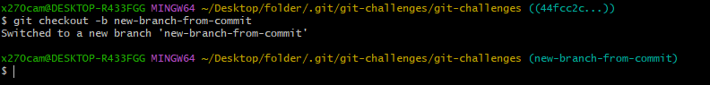 git checkout -b new-branch-from-commit::# # Create a new branch from detached HEAD to keep the commit.

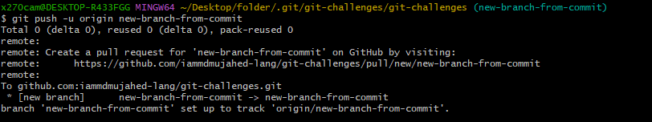 git push -u origin new-branch-from-commit::#

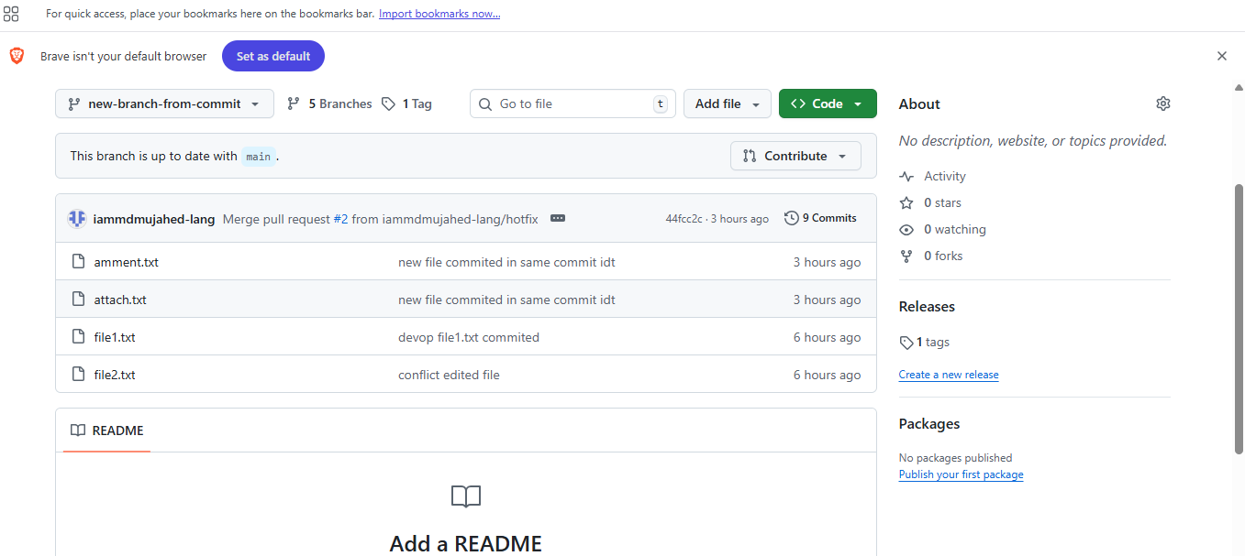

1. **Git Hooks Challenge**
   * Configure a pre-commit hook to reject commits without a message format (e.g., must start with JIRA-XXX).
   * First ceate a file called commit-msg.
   * Then edit the file and add script.
   * Vi .git/hooks/commit-msg# thid commsnfd to edit the file and add the selected commit script in this.

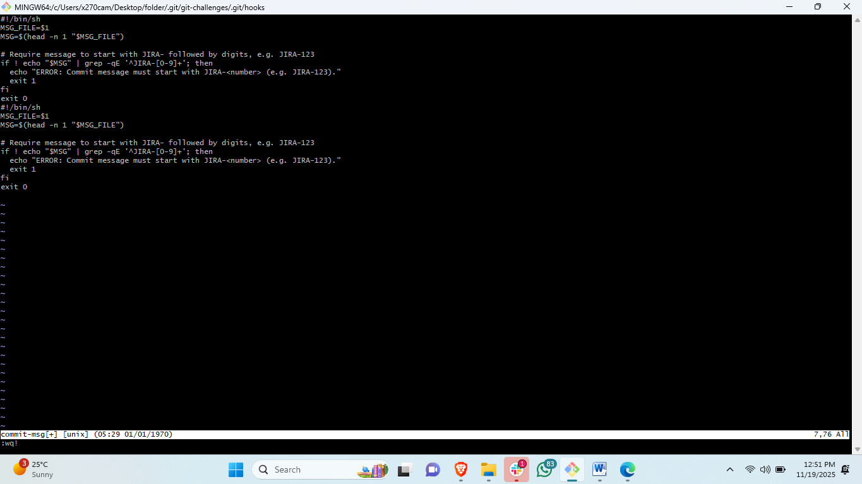

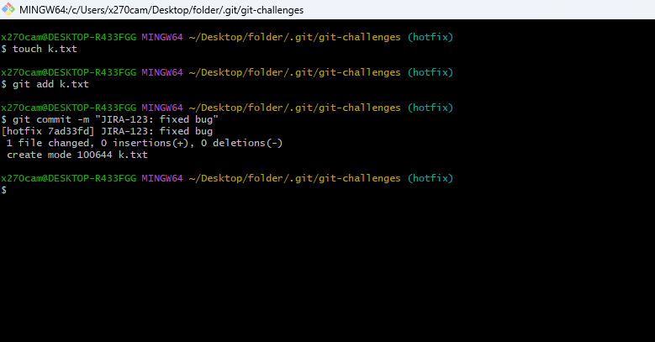

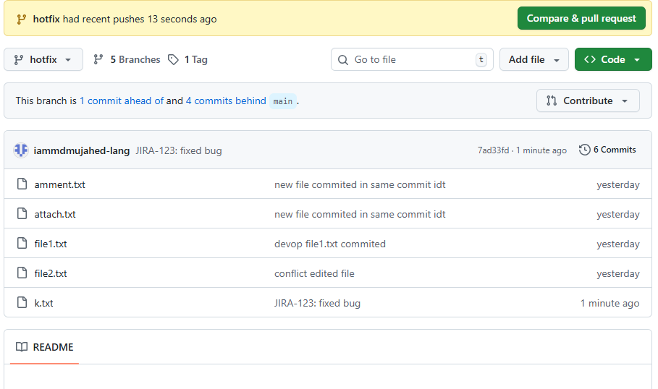

Then# add this filke and push to branch.

1. **Squash Merge vs Rebase Merge**
   * Show the difference between squash merge and rebase merge with evidence.
   *  

Steps for squash:first checkout to new branch and create one file and commit then

Swithch to main branch and merge with squash <git merge –squash “newbranchname” it will merge but it will not create anethor commit for merging.

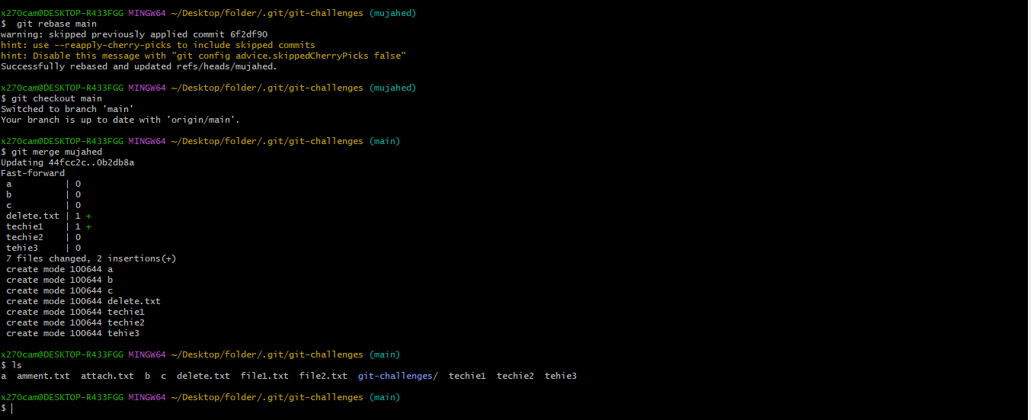

Steps to rebase: checkout to new branch and create one file and then commit and again switchto main branch :

# <git rebase “new branch”> it will rebase.

1. **Fork & Pull Request Workflow**
   * Fork a repo, make a change, and submit a pull request to the original repo.

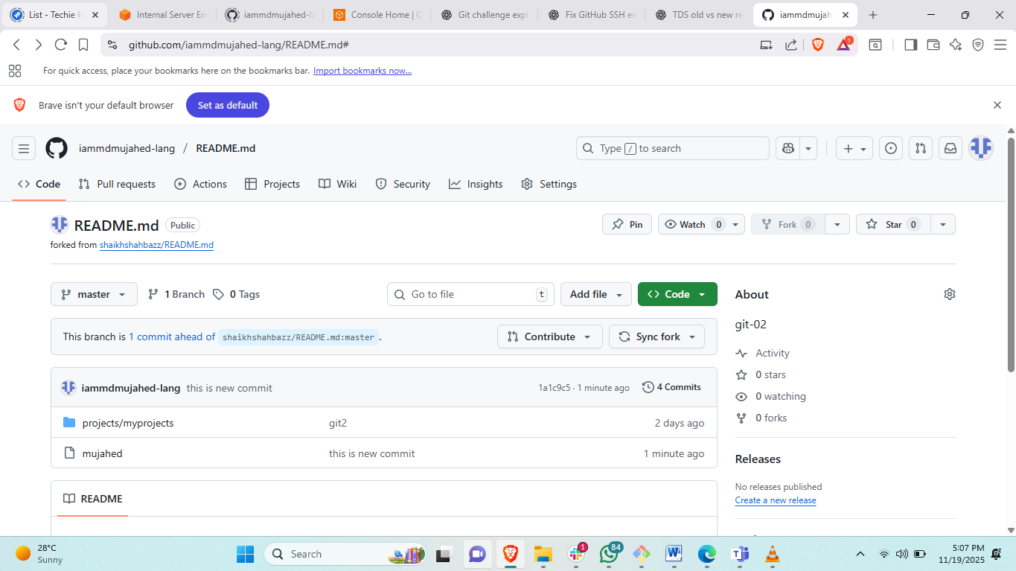

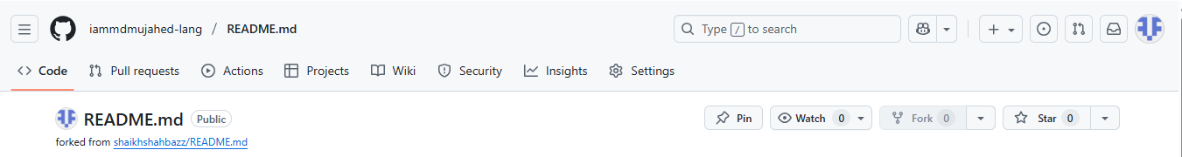

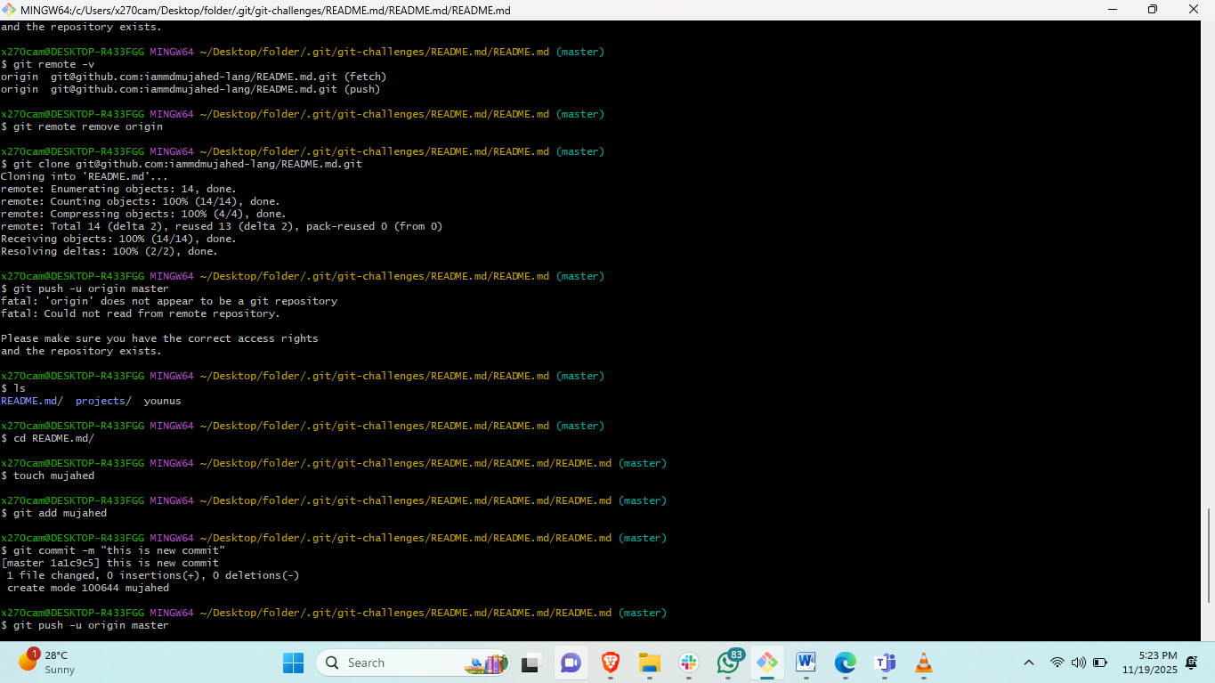

Steps: first we ask for a friend to share repo “httpd URL” and open this url in web browser.

And create fork.

#then go to your local repo and add clone your friend ssh URL and then clone it.

#then change to cloned directory and make a commit and push. Take screenshort.

1. **Recover Lost Commit**
   * Commit something, reset hard, and then recover it using git reflog.

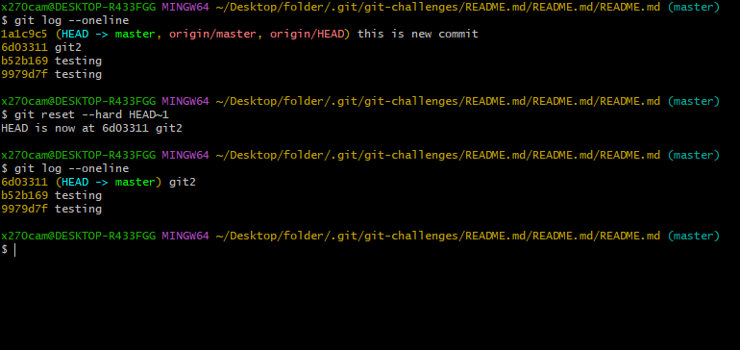

First I delete the head commit:< git reset --hard HEAD~1>.

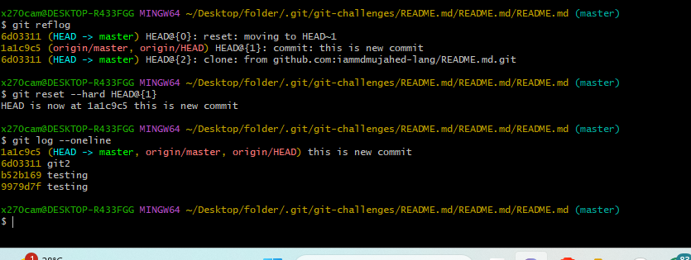

#then check the logs it will change.

#< git reset --hard HEAD@{1}>this will recover the recent deleted commit and then chack logs.<git log –oneline>.s